Comprehensive Perinatal Services Program

Welcome to UCSF Obstetrics! We look forward to partnering with you on this journey and invite you to join the Comprehensive Perinatal Services Program.
How the program works
To qualify, you must be a pregnant patient at UCSF with Medi-Cal insurance. A Healthcare Navigator will be assigned to your prenatal team and will meet with you once every trimester and once postpartum via video visit. The Healthcare Navigator will ask you questions to determine what resources and referrals might be helpful for you and your family. There is no cost to you for this program, it is completely voluntary and is in addition to all the routine prenatal care you get at UCSF! Examples of what the Healthcare Navigator can help you with include:

- Referrals: WIC, doula, home visiting nurse, social worker, dentist, registered dietician
- Community resources: pregnancy support groups, food, transportation
- Basic nutrition services
- Blood pressure monitoring
- Concerns about living situation
- Financial challenges
- Mental and emotional health
- Labor and delivery information
- Lactation
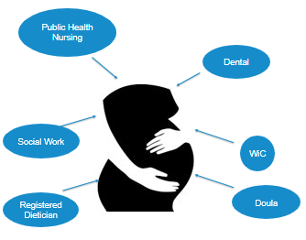


Enrolling in the program
If you have Medi-Cal insurance and would like to schedule a video visit with a CPSP Healthcare Navigator, please inform your UCSF OB provider, the front desk at your UCSF OB clinic, or call the main number to UCSF prenatal clinics and ask about the program: 415-353-3400.
Completing the program

After your postpartum video visit with the Healthcare Navigator and any needed resources or referrals are provided, you have completed the program.

